project in wireless communication report
Koustubh sharma

Task 1
As the given setup conditions, the system was implemented and the BER was calculated. We generated a base pulse which was mapped to QPSK modulation and sent over the channel where we added the noise and on the receiver side we first matched the received signal and then down converted, sampled and demodulated to find out the BER.
QPSK Modulation
Generate base pulse
Up conversion
Matched filter
Down Convert
Sampling
Channel
Demodulate
Calculate BER

Fig 1. Steps taken to obtain the BER
This figure below shows the resulting BER curve obtained:

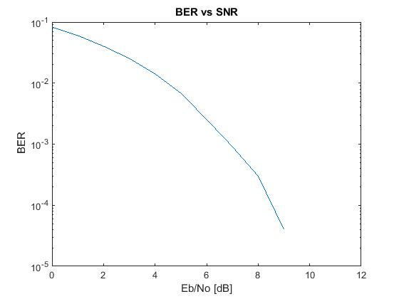
Fig 2. Obtained BER curve

Task 2
We decoded the given signal similar to task 1 and the following message was decoded from the signal:
Turbo Codes were invented by Berrou, Glavieux and Thitimajshima 1993.

Down Conversion
Matched Filter implementation
ASCII value
Demodulate
Message
Sync & Sample
Signal

Fig 3. System implementation to extract out message from signal

Task 3
Similar to task 2 we were given the signal, we filtered the signal using the Butterworth filter, the maximal signal represented the pilot which was estimated and then CP was removed and then FFT was done. After channel estimation and demodulating the QPSK symbols we decode the Viterbi Algorithm to obtained the following message from the signal:
Any linear combination of Gaussian random variables is again a Gaussian random variable.

Down Conversion

Signal
D/A conversion

FFT

CP removal

Demodulate
Sync & Sample

Decode & convert to ASCII
Message

Fig 4. System implementation to extract out message from signal

